SPRING DATA JPA WITH SPRING BOOT, HIBERNATE

MANDATORY EXERCISES
WEEK 2:
EXERCISE 1:
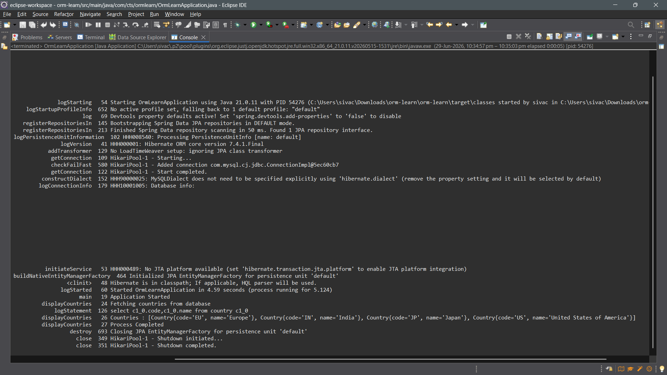
POM.XML:
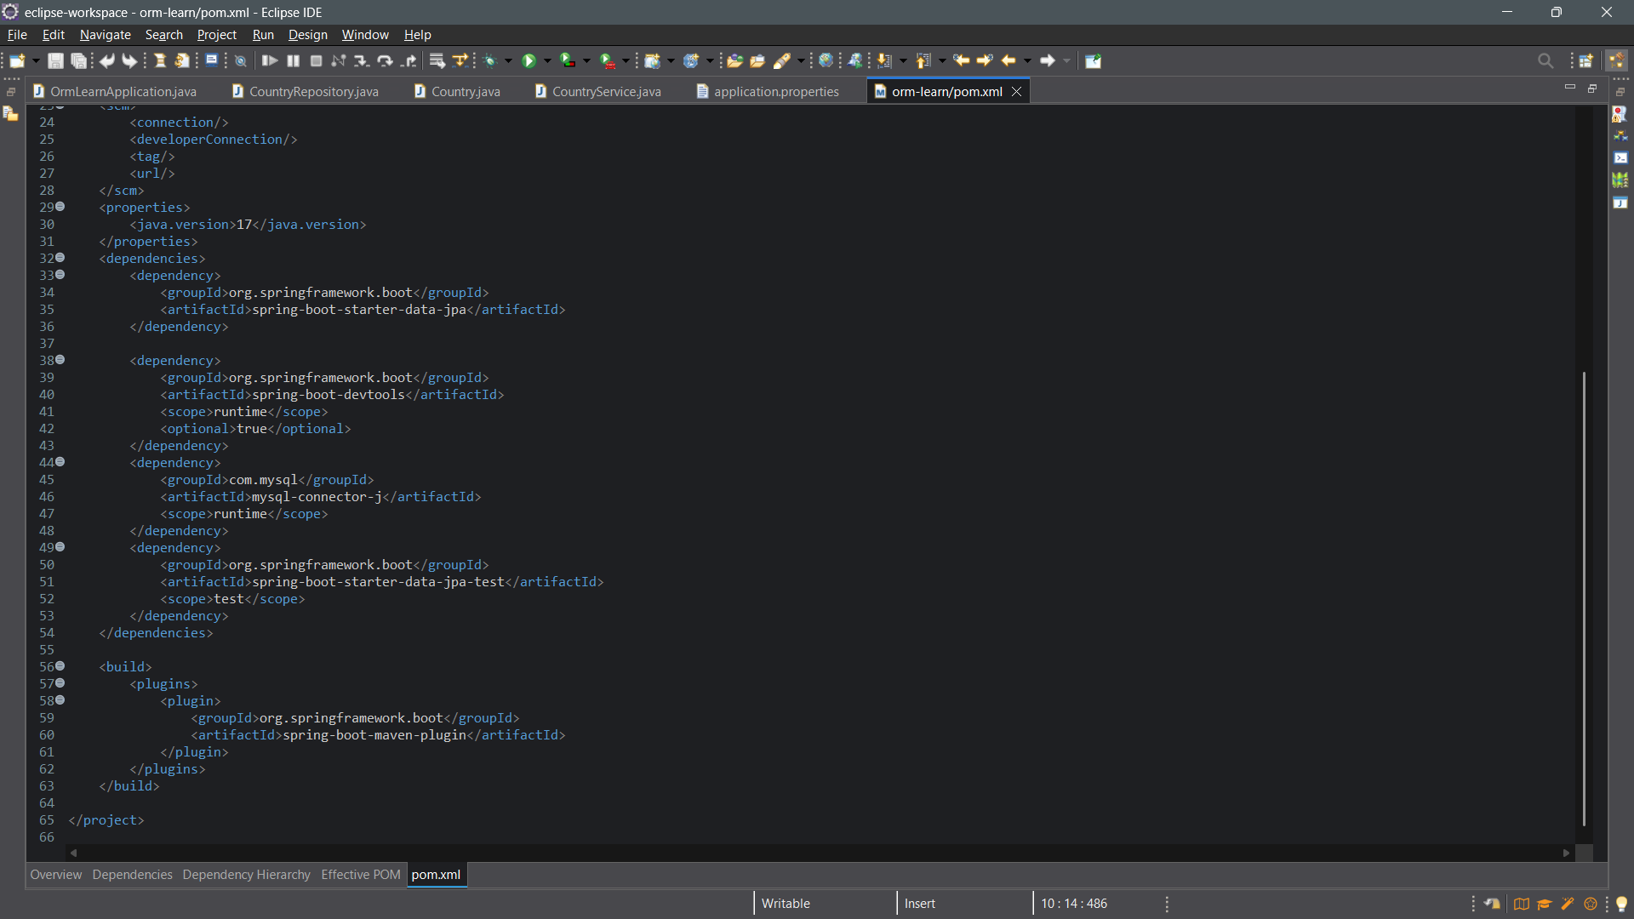
PROJECT STRUCTURE:
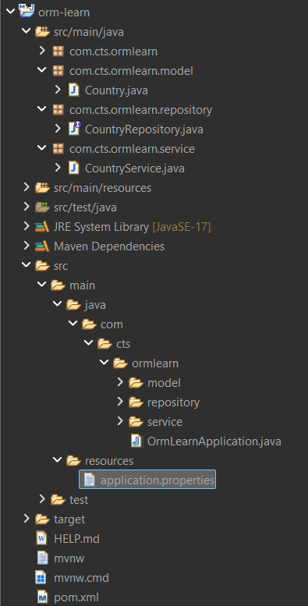

APPLICATION.PROPERTIES
